**SOMANATH SAHOO**

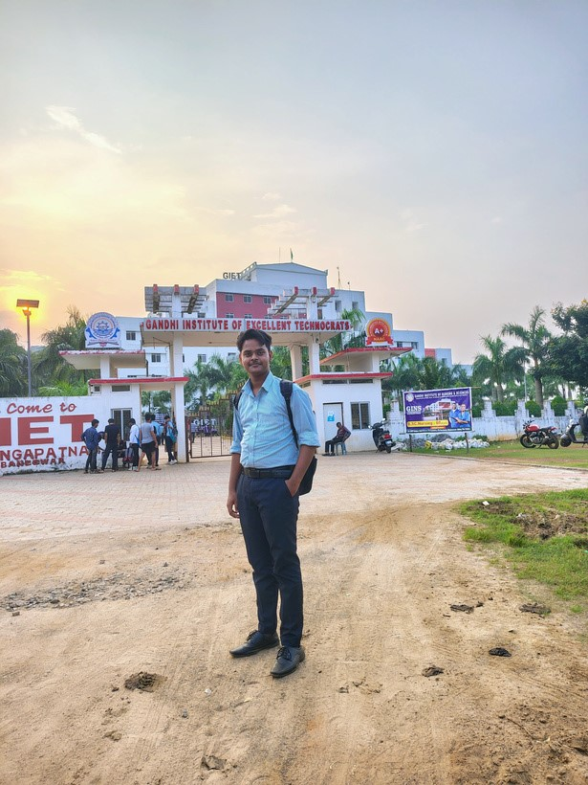

7854830415

somanathsahoo830@gmail.

com

ODISHA,BHUBANESWAR ,

AT/PO-KARAMUL

**Contact**

To get opportunity where I can make the best of potential and contribute to the organization growth.

**Skills**

**About Me**

Cybersecurity

Data structure

Web Desing

Communication

Graphic Design

English

French

**Language**

Graphics Designer &

Software developer

**Education**

# 2021-2024(DIPLOMA)

**GOVT POLYTECHNIC DHENKANAl**

# 2024-2027(GRADUATION)

**GANDHI INSTITUTE OF EXCELLENT TECHNOLOGY**

**CERTIFICATION**

* Git hub certificate developer
* CompTIA cybersecurity Analyst
* Certificated for Ethical hacking

**INSTITUTE TREND**

* Artificial intelligence(AI)
* Machine learning(ML)
* Cloud Computing(CC)
* Cybersecurity
* Internet of Things

**DECLARATION**

I hereby declare that the information furnished above are true and authentic to the best of my knowledge.

**REFERENCE**

Wardiere Inc./CTO

SOMANATH SAHOO

Phone no:-7854830415

Email:- somanathsahoo830@gmail.com